I: Steganographic Process

The process takes as input a character String and a Bitmap image. The Bitmap is treated as ARGB_8888 format where each pixel consists of an alpha, red, green, and blue value of 8 bits. The Bitmap is processed into an integer buffer, with each integer holding the Color value of one pixel. Android stores Color values in premultiplied format where the alpha is multiplied into the RGB values. The pixel manipulation functions in the Android library conduct background multiplication and division to retrieve and set the RGB values. To avoid rounding errors, this application instead reads the unprocessed pixel data into the integer array for further use.

The character String is broken down into its component nibbles. Each bit of the nibble is stored in the corresponding lower order bits of a pixel’s ARGB fields.

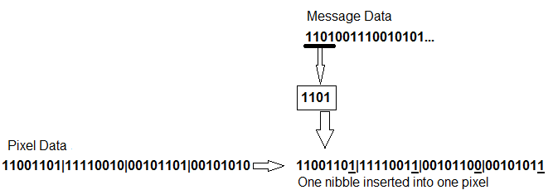

II: Definitions  
  
Multimedia Message Service (MMS): A standard protocol for sending multimedia content to and from mobile phones over a cellular networks. It is an extension of the Short Messaging Service (SMS) protocol and was first deployed in the early 2000s. The MMS protocol does not require device manufacturers to implement lossless compression and decompression. Neither does the protocol require carriers to implement lossless transcoding and content adaption between different networks.